|  |
| --- |
| Kyrgyz State Technical University |
| Software Engineering Methods |
| Laboratory work 3 |

|  |
| --- |
| Abakirov Nursultan SE(eng)1-16 |

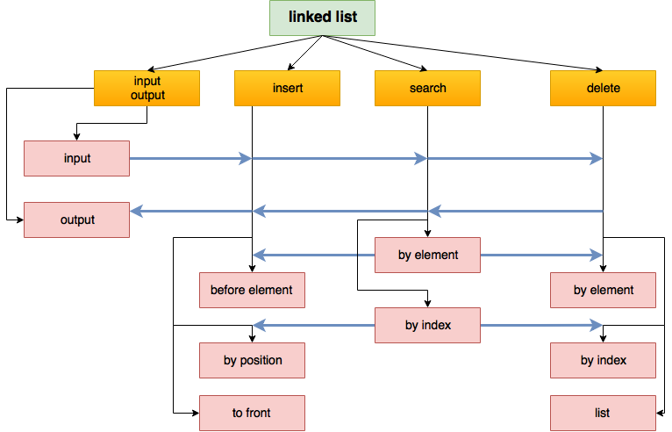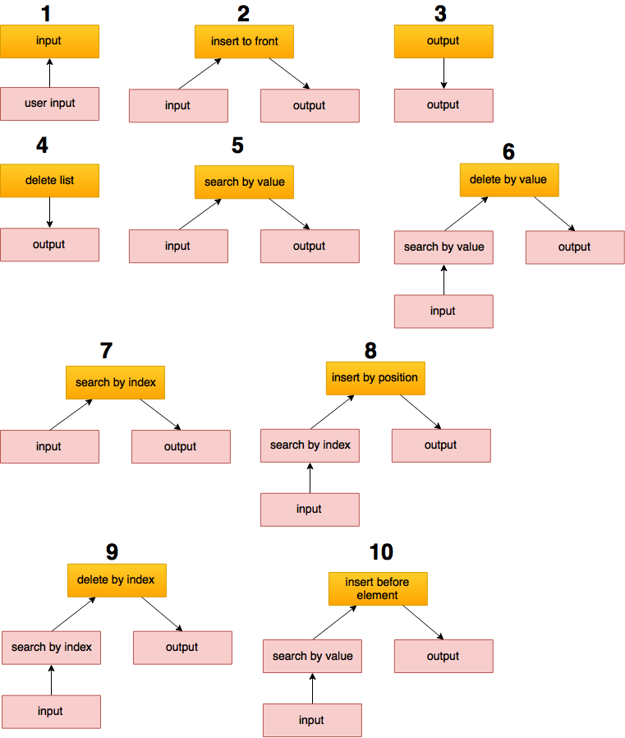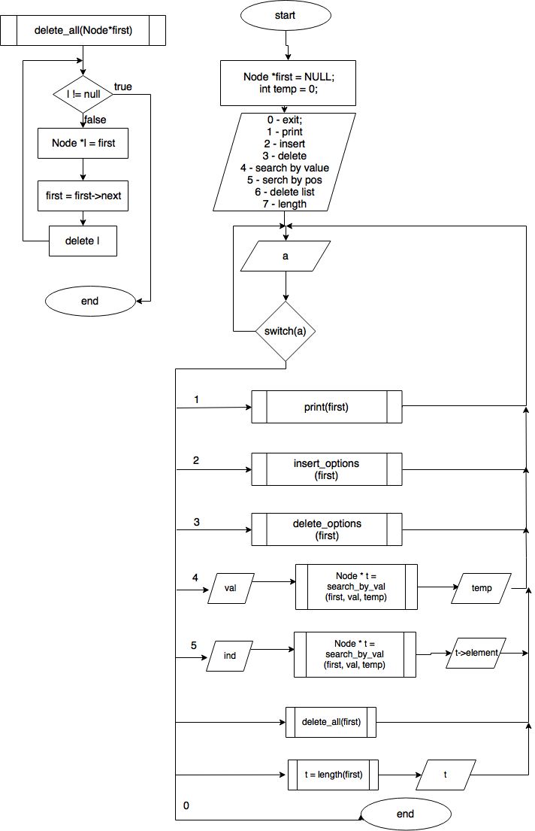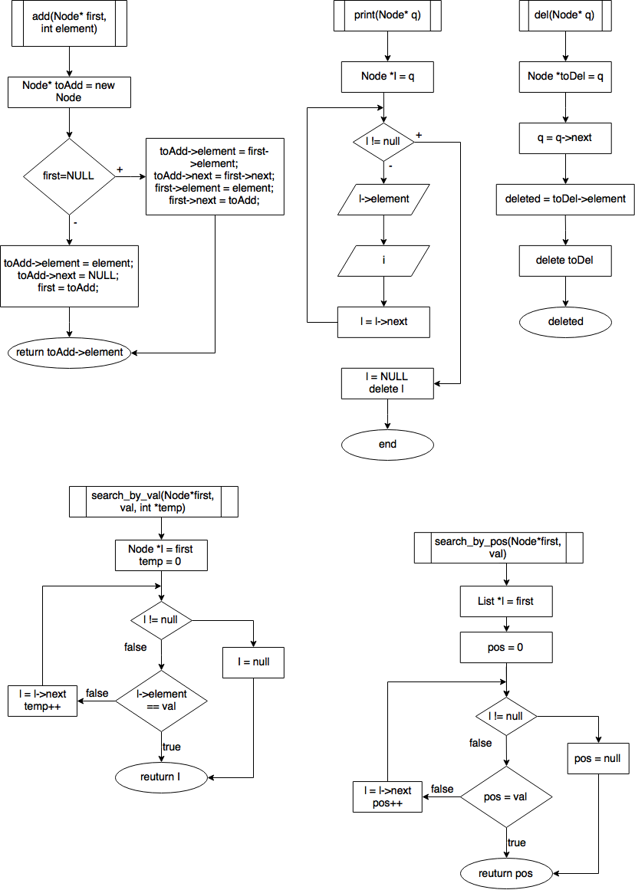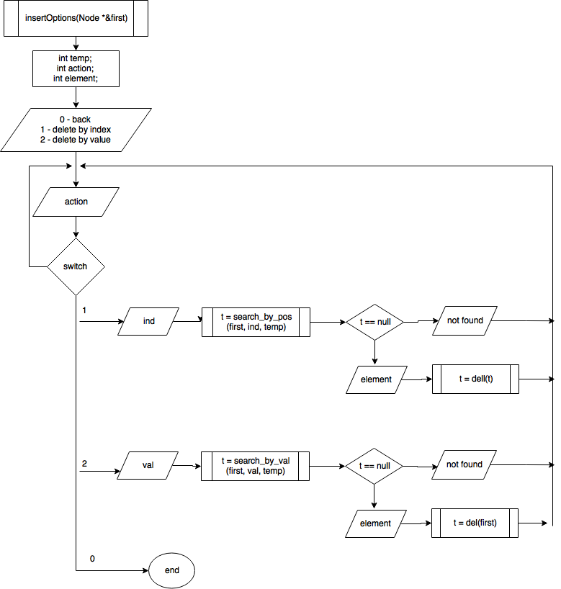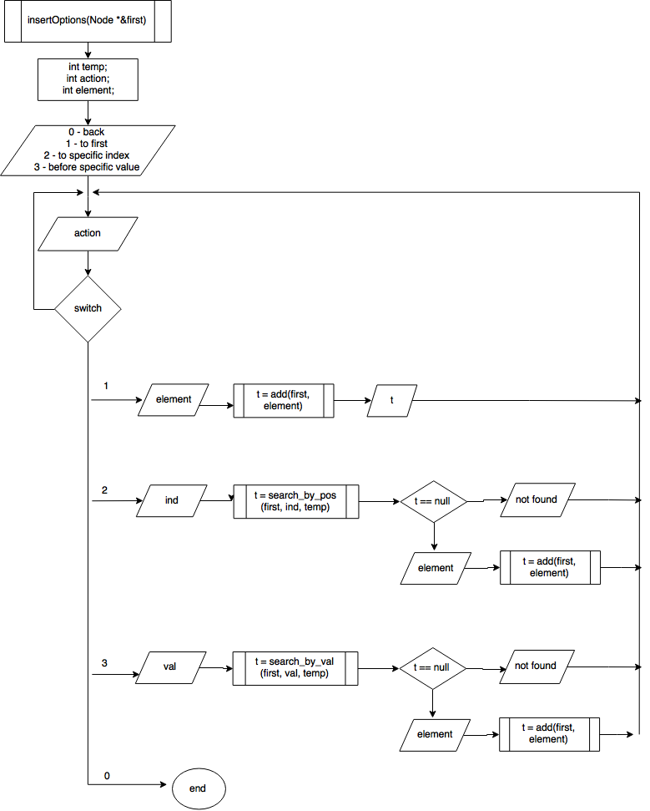

Design program of one lined list

With functions

* Adding an element to the list to the first position
* Adding an element to the list by position
* Adding an element to the list before specific value
* Deleting an element by position
* Deleting an element by set value
* Search an element by value in the list
* Search an element by position in the list
* Output of the list elements
* Deleting of the list.

**Requirements:**

Type of Input must be an integer.

**Design of diagrams.**

**Design** - The structural method – decomposition.